*MODULE 4: BUILD YOUR OWN PBX WITH ASTERISK*

In Module 4, we developed a PBX system using a PC running the Linphone softphone application and a Raspberry Pi Model 3 running Asterisk. To run and install Asterisk, the Raspberry Pi Model 3 was booted into Raspbian Linux.

1. **How much memory is used by the code?** The memory used by Asterisk is 2.4 MB.

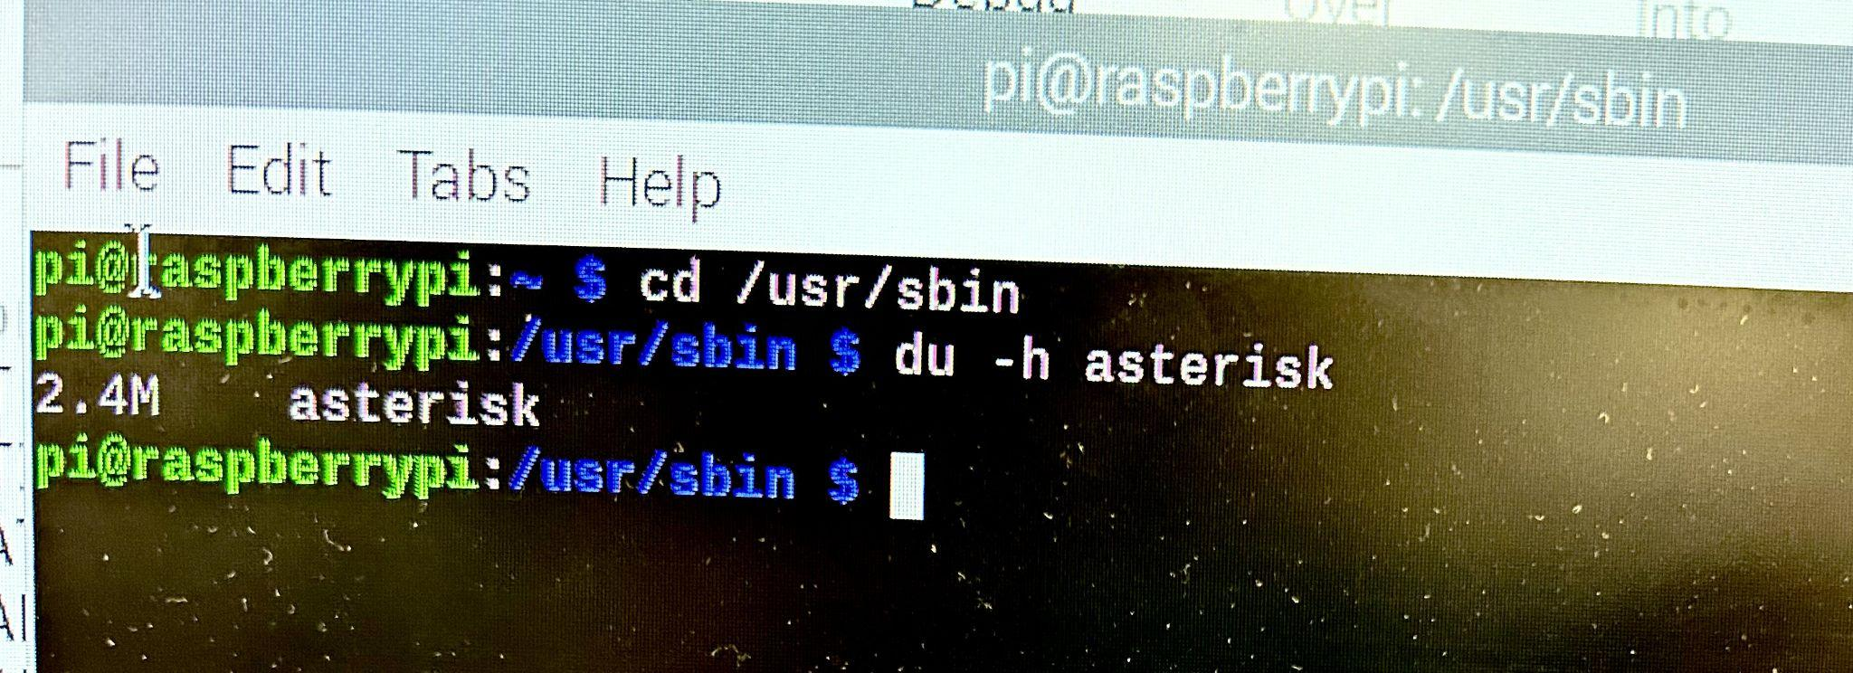

1. **Using either a SIP phone plugged into the same LAN as the Raspberry Pi Model 3 (you may need an Ethernet switch to create the network), or with a PC running a softphone application connected to the Raspberry Pi Model 3, configure Asterisk to provide a voicemail message at extension 100. Configure your SIP phone or softphone and register with Asterisk. Show your Asterisk setup in a screenshot.**

To configure Asterisk to provide a voicemail message at extension 100, first we move to the asterisk directory where all asterisk files are located using the command *cd /etc/asterisk*.

We then backup the sample extensions.conf file and create a new one. We proceed to edit the extensions.conf with a dialplan to answer the call at extension 100, play a hello world message, and end the call. Backing up the sample extensions.conf and creating a new one is done by using the command *mv extensions.conf extensions.sample*. Editing the extensions.conf is done by *sudo nano extensions.conf*.

The configuration for extensions.conf is seen below:

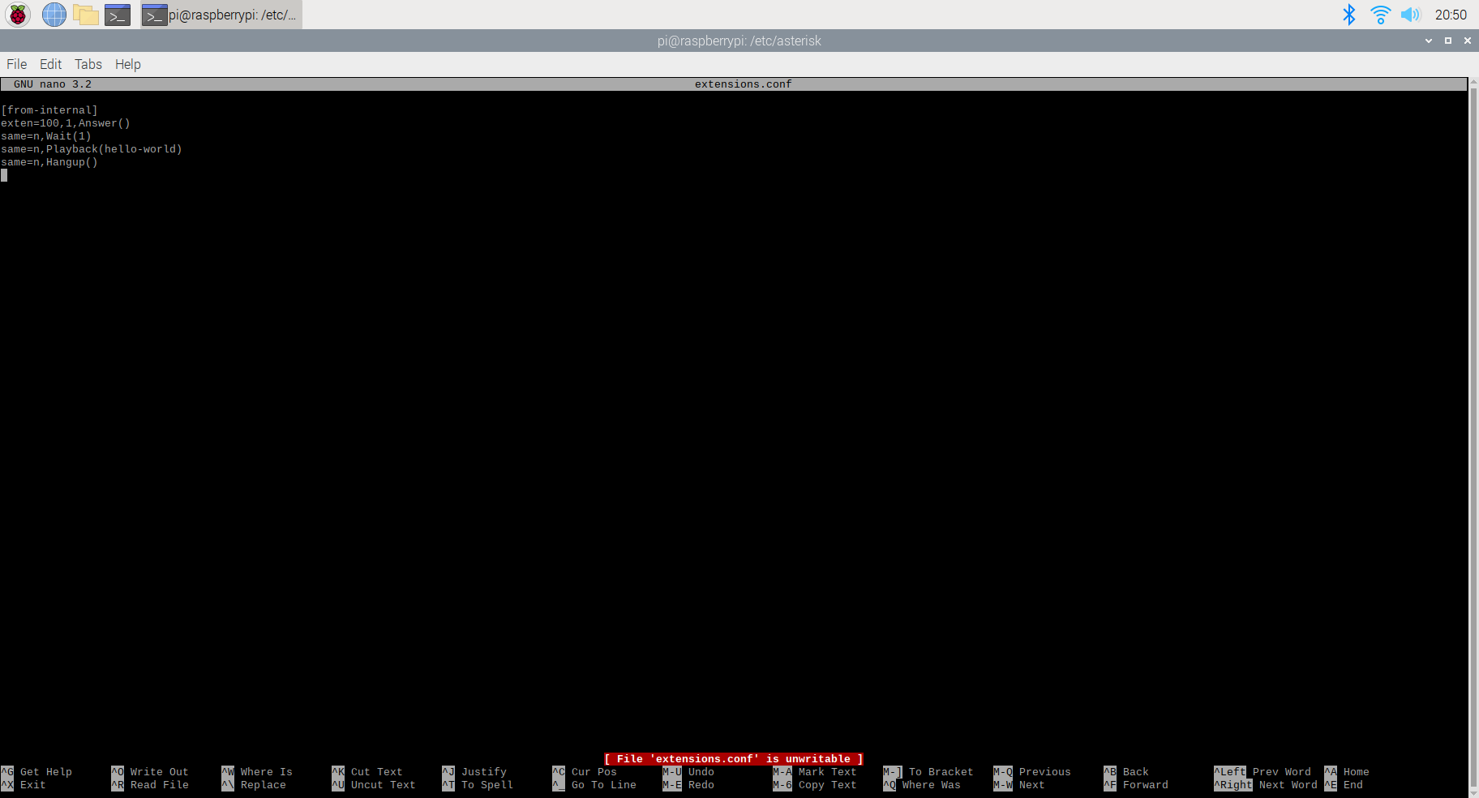

Next we configure the SIP channel driver to manage SIP communication. We first backup the sample sip.conf file and create a new one. Since we are running Asterisk version 16.28.0, we proceed to edit the pjsip.conf. We configure the endpoint for our SIP softphone to connect to (6001). Backing up the sample pjsip.conf and creating a new one is done by using the command *mv pjsip.conf extensions.sample*. Editing the pjsip.conf is done by *sudo nano pjsip.conf*.

The configuration for pjsip.conf is seen below:

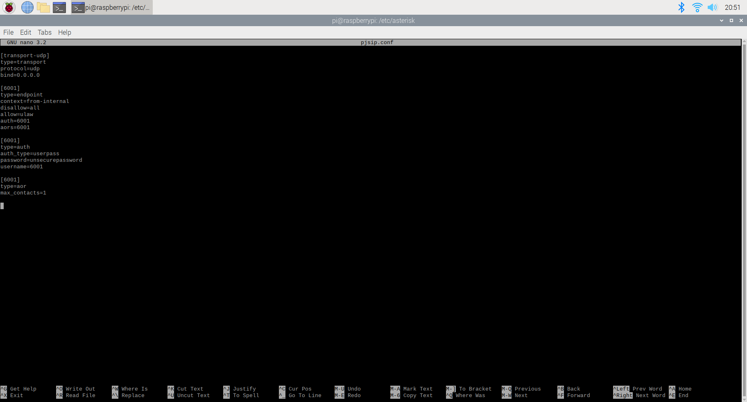

The Asterisk setup is highlighted in the screenshot below:



1. **Make a call to extension 100 and record what you hear. Show your Asterisk setup in a screenshot.** Asterisk was started with a control console and level 5 verbosity specifying the detail of the console logs using the command *asterisk -cvvvvv*. After the softphone was configured to connect to the Asterisk server, Asterisk was restarted and connected to using the following commands: *asterisk -rx “core restart now”* and *asterisk -rvvvvv*. The Asterisk setup can be seen in the screenshot below:

Successful debug messages indicating the call has been answered by Asterisk and the hello world voicemail message has played is seen in blue within the screenshot below.



Linphone was setup by creating an SIP account in which the username is the endpoint that was setup in the Asterisk configuration, the SIP domain which is the IP address of the Raspberry Pi, the password which is the secret password setup in the Asterisk configuration, and UDP transport protocol.

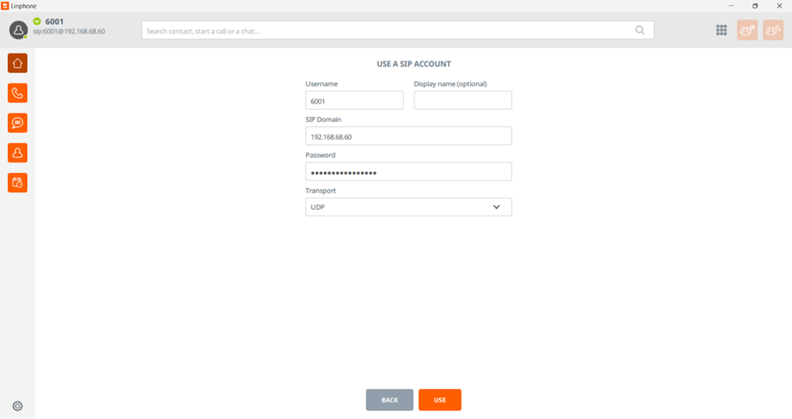

A call was then placed to the extension 100, and a voicemail message was played which said “Hello World”.

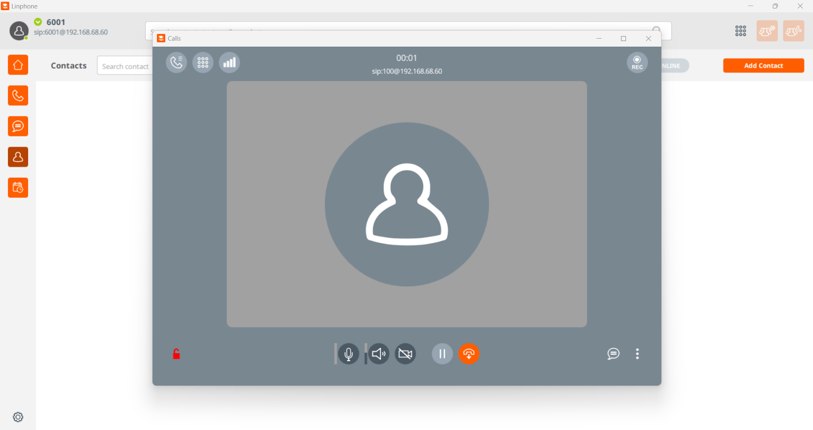

1. **[Optional, for 5 extra credit points] Add another SIP phone or softphone to the network, and make a phone to phone call.** Another softphone was added to the network by registering another SIP phone in the *pjsip.conf* file as seen below:

We configure the endpoint for our other SIP softphone to connect to (6002).

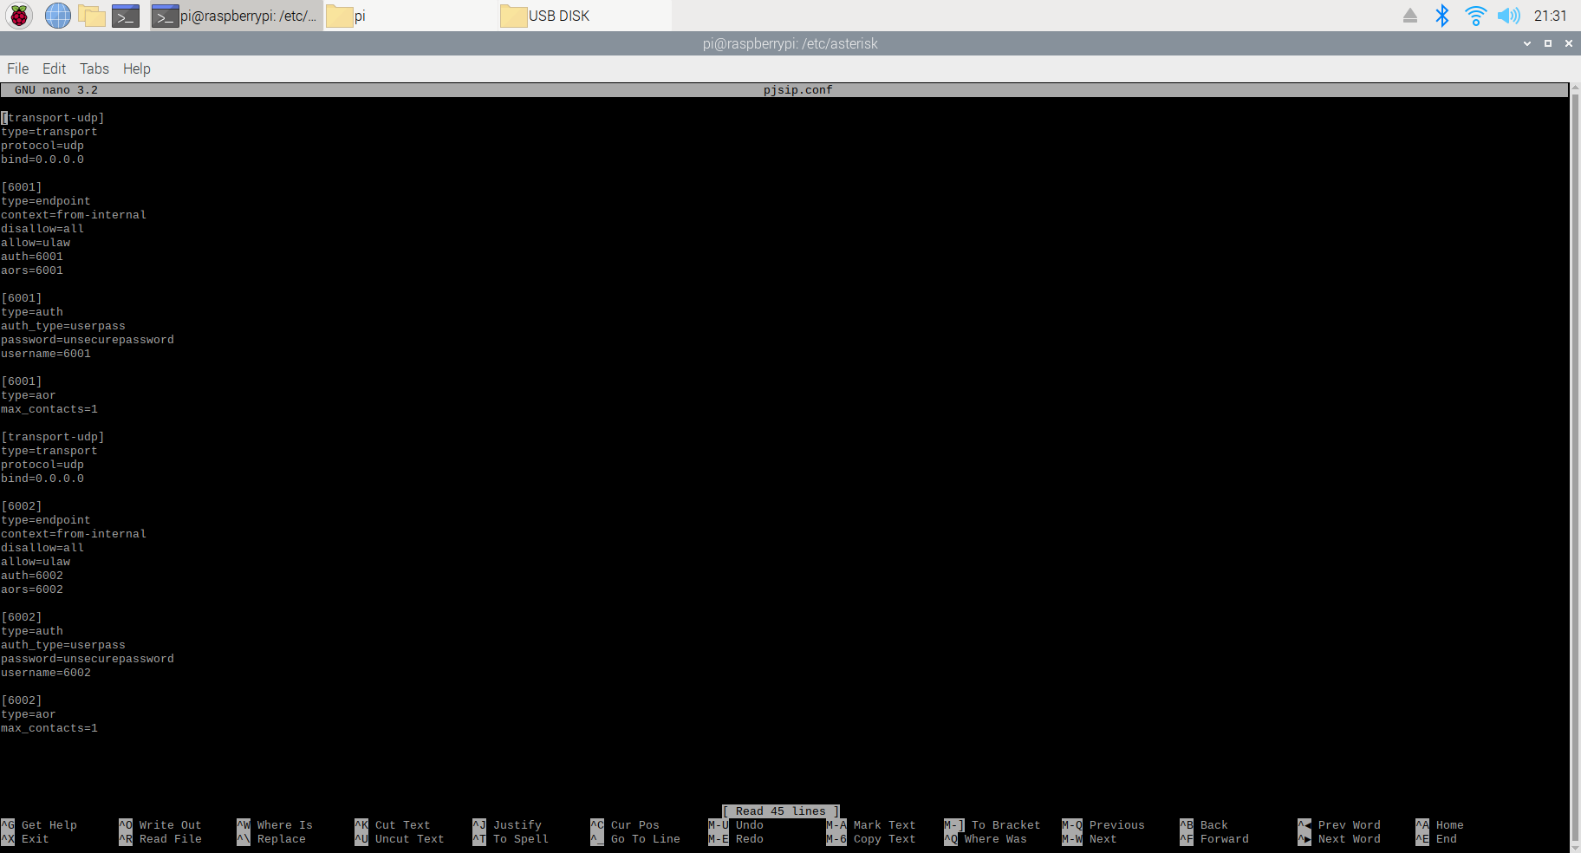

We then handle calls that are placed at extensions 6001 and 6002 to dial corresponding SIP softphones, initiating a phone to phone call. The Asterisk setup in the *extensions.conf* file can be seen below: